Troop Direct Ship Link

NEW this year. Your Girl Scout troop can set up a Troop Site that enables customers looking for Girl Scout Cookies to support your troop with a Shipped or Donated cookie order.


The first time a leader or cookie volunteer for the troop logs in to their volunteer role in Digital Cookie, she will see a place to begin the process to have a troop shipped link.
To begin, click the “Start” button.

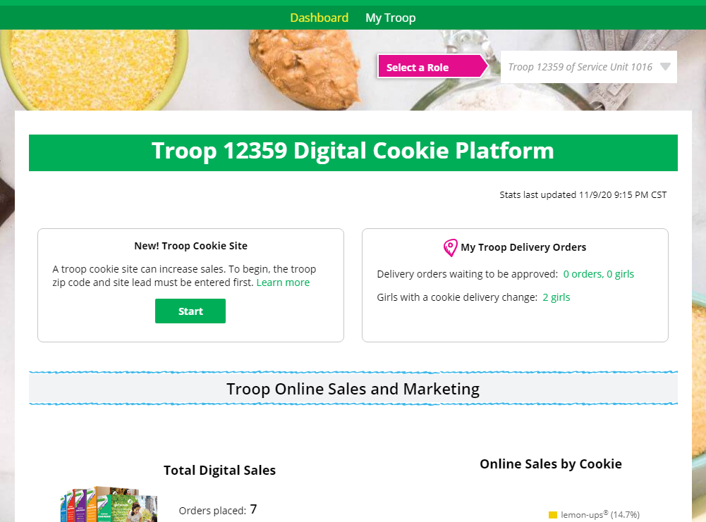
Start


You will be asked to enter a zip code for your troop. Enter one that is representative of the majority of the girls in your troop

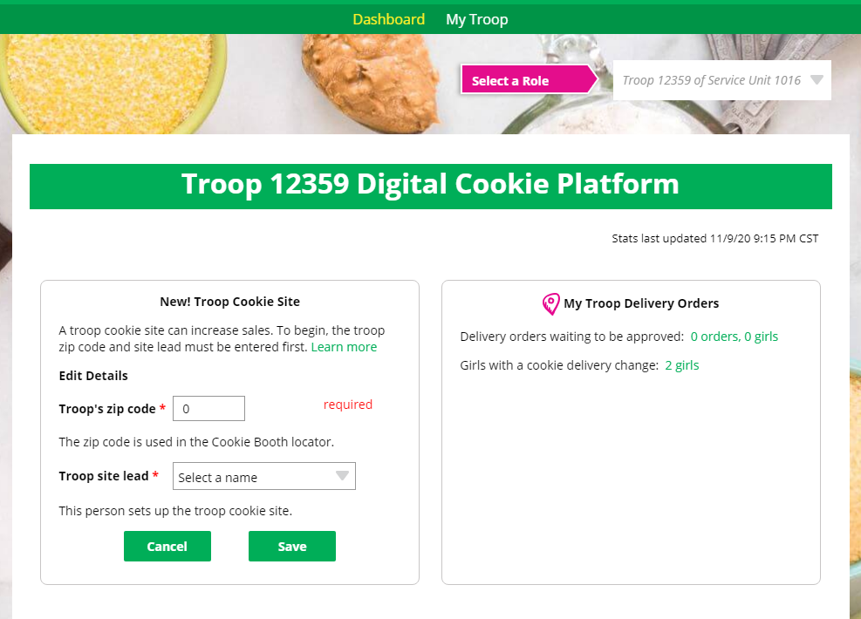

You will also select a name from the drop down of one of the volunteers from the troop to serve in the role of “Troop site lead”. The Troop site lead will be responsible for working with the girls in the troop to set up their site.

Once the first volunteer for the troop has made those selections, everyone will see the selections that have been made and can change them if needed.

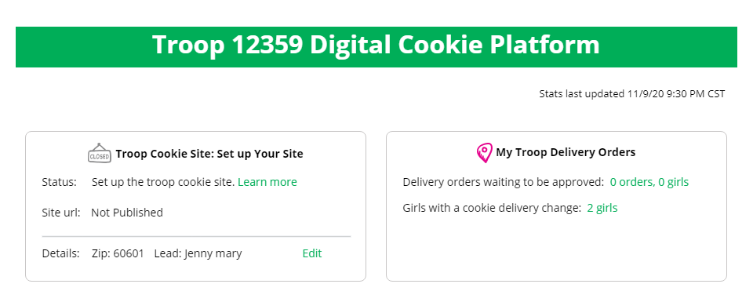


The Volunteer designated as the Troop Site Lead can login to Digital Cookie and select the “parent” role.
At that point, she will be able to select the Troop as one of her Girl Scouts from the drop down at the top of her page.
` 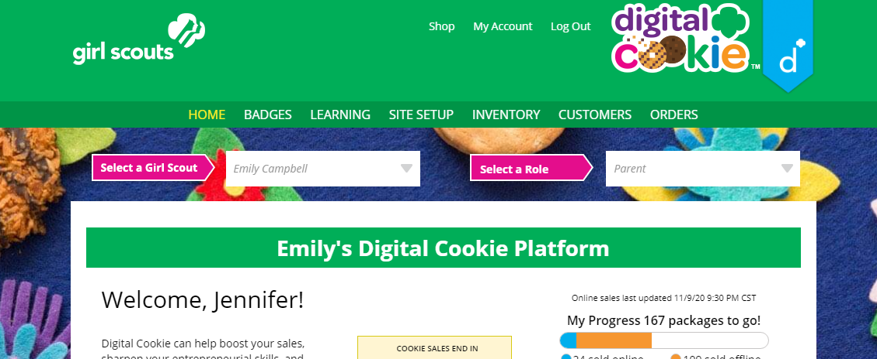
Select the Troop as the Girl Scout

She will need to complete the registration process as if the troop were a new girl by signing the Terms & Conditions statements and Girl Pledge, plus registering her name. It is important to leave the Preferred First Name as it appears so that your Troop URL is correct. If there is an issue with the troop number, please contact your Council Customer Care to resolve before proceeding.

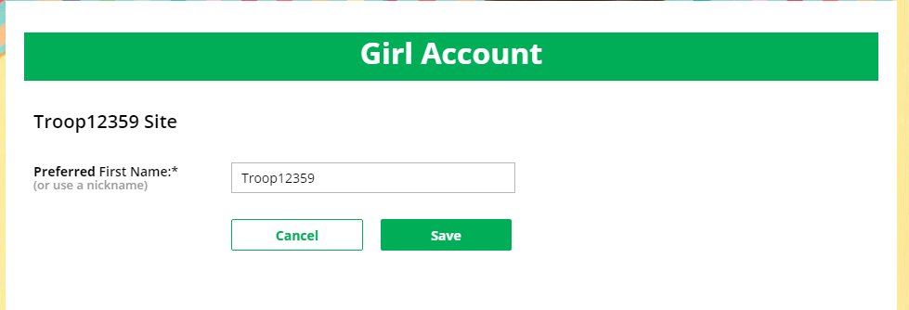

After that, the Troop Site Lead will use the “Site Setup” to work with the girls in the troop to create their message and photo/video.
Once the site is published and the council’s sale is live, the troop’s link is available and will be added to the Cookie Finder when it is active for the season.

Troop Direct Ship Link FAQ’s

- What do I need to do to get my link on the cookie finder?
Just set up the troop’s link and publish it. It will automatically be added to the Cookie Finder when the Cookie Finder is activated.

- What happens to sales that come in from the cookie finder on my link?
The sales will appear in eBudde under the girl orders tab for the girl named “Troop#####”.

- How do girls get credit for the sales from the link?
The Troop Cookie Manager will divide the cookies sold among the girls in the troop in eBudde-the order management software that she uses for managing the sale

- When is the link active?
Troops can use their link once the setup appear on their homepage and they publish their site. The links will appear in the Cookie Finder in early February.

- Why is it only shipping?
For links that appear in the cookie finder, they will only have shipping and donation available for the customer. We did not want a troop link where the customer is a complete stranger and may want girl delivery that the troop is unable to deliver.

- Can I use my link for other purposes?
The link will be available for the troop to use as soon as your council enables that feature and the troop sets up the link. If the troop needs a shipping/donation only link where the sales credit would go to the troop and not an individual girl in the troop, the link is available to share once the site is setup and published.

